**Srikanth and Sindhu scale summit at Sr. Nationals**

Return to frontpage New Delhi, December 23, 2013

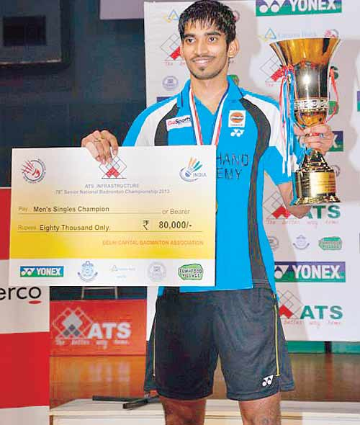 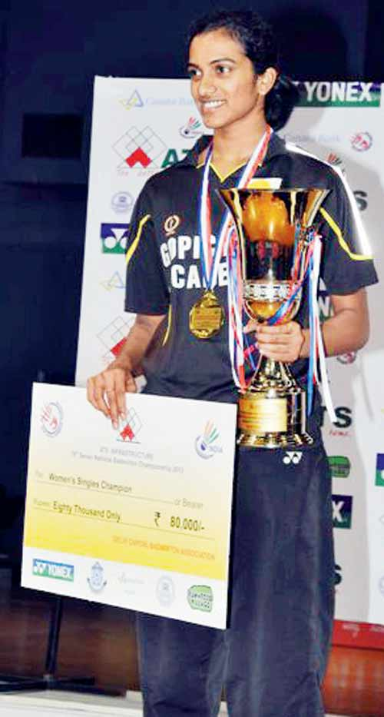

None of the finals went the distance but there was no dearth of excitement as two new Champions were crowned and two others regained the honour in the ATS Sr. National Badminton Championship - 2013.

A display of determination turned out to the theme of the day with an all-attacking K. Srikanth, ranked 37th in the world, coming up with a standout performance.

Earlier the duo of Pranav Chopra and Akshay Dewalkar besides the together-again pair of G. Jwala and Ashwini Ponnappa proving a point on the big stage by winning their grudge-matches.

**Biggest moment**

Srikanth, winner of the Thailand Open Grand Prix title in June, enjoyed his biggest moment before the domestic audience by stopping second seed R.M. V.Gurusaidatt 21-13, 22-20 for the singles title worth Rs. 80,000.

In an action-filled final lasting 40 minutes, Srikanth’s superior speed made the difference. A compulsive attacker, Srikanth met the shuttle early and came up with a variety of strokes that Gurusaidatt was unable to deal with. Srikanth had meted out a similar treatment to top seed P. Kashyap on Sunday.

**P.V. Sindhu easily regained the Title**

Second seed P.V. Sindhu easily regained the title she lost last October by overpowering fellow-18-year-old Rituparna Das 21-11, 21-17 in 30 minutes.

“We play everyday and it is good to see her doing so well to reach the final,” said a smiling Sindhu, giving all credit to Rituparna for her display. Sindhu received Rs. 80,000, twice of what Rituparna got for her maiden final-appearance.

After the Mixed Doubles final saw second seeds Arun Vishnu and Aparna Balan retain the crown by beating top seeds K. Tarun and and Ashwini Ponnappa in 29 minutes, the two other Doubles finals proved more exciting.

Chopra and Dewalkar avenged the defeat suffered in the last year’s Men’s Doubles final to Manu Attri and Sumeet Reddy. The 21-19, 21-17 victory in 39 minutes earned the winners their first National title.

Jwala and Ashwini upstaged top seeds Pradnya Gadre and Sikki Reddy to regain the title won in the 2009 edition. Having lost to Pradnya and Sikki last Sunday in Mumbai, Jwala and Ashwini controlled the match and were never seriously challenged in the 34-minute match. All Doubles winners received Rs. 80,000 and the runners-up, Rs. 40,000.

# Kuhoo, Chirag youngest medal winners

Shuttlers Kuhoo Garg and Chirag Sen became the youngest players to win a medal in 78th Senior National Badminton Championship when they defeated Pranaav Chopra and Maneesha K in Mixed Doubles Quarterfinals at the Siri Fort Stadium. The unheralded pair clinched the Bronze Medal on their maiden appearance in the Nationals. However, Kuhoo and Chirag suffered a 9-21 11-21 defeat to the experienced combo of Arun Vishnu and Aparna Balan, seeded second, in the Semifinals.

Kuhoo and Chirag, who are in the Under-17 age category, reached the Quarterfinals after beating fourth seeded players Rachita Sahdev and Abhinav Manota. The Uttarakhand shuttlers had participated for the first time in Senior National Badminton Championship and won the Bronze medal.

Kuhoo, who is a recipient of Sports Scholarship from ONGC, was selected for Indian Junior team and had participated in Badminton Asia Youth U-19 Championships at Malaysia in July this year. She also participated in U-17 Badminton Asia Youth Championships held in Kudos, Indonesia in October where she reached Quarterfinals. She also participated in Junior World Championships 2013 in Bangkok, Thailand from October 23 to November 3.

**The Results (finals):**

**Men Singles:** 5-K. Srikanth (Pet) bt 2-R. M. V. Gurusaidatt (Pet) 21-13, 22-20.

**Women Singles:** 2-P. V. Sindhu (Pet) bt 15-Rituparna Das (AP) 21-11, 21-17.

**Men Doubles:** 1-Pranaav Chopra (Pet) and Akshay Dewalkar (AI) bt 2-Manu Attri (AAI) and Sumeeth Reddy (AP) 21-19, 21-17.

**Women Doubles:** 2-G. Jwala and Ashwini Ponnappa (Pet) bt Pradnya Gadre and N. Sikki Reddy (AAI) 21-17, 21-16.

**Mixed Doubles:** 2-Arun Vishnu and Aparna Balan (Pet) bt 1-K. Tarun and Ashwini Ponnappa (Pet) 21-10, 21-17.

-----------------------------